# Dependent Variable: INJSEV_IM

|  |  |  |  |  |
| --- | --- | --- | --- | --- |
| Algorithm | # of independent variables | Cross validation? | tuning? | Accuracy |
| KNN | 98 |  |  | 0.6980 |
| SVC | 98 |  |  | 0.7143 |
| DT | 98 |  |  | 0.8407 |
| RF | 98 |  |  | 0.8410 |
| XGBoost | 98 |  |  | 0.8770 |
| LGBM | 98 |  |  | 0.8407 |

**Feature importance Result:**

**XGBOOST feature importance TOP 15**

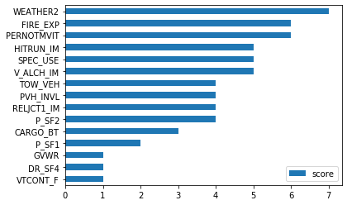

**More observations (confusing matrix etc.):**

# Dependent Variable: MXVSEV_IM

|  |  |  |  |  |
| --- | --- | --- | --- | --- |
| Algorithm | # of independent variables | Cross validation? | tuning? | Accuracy |
| KNN | 85 |  |  | 0.6510 |
| SVC | 85 |  |  | 0.6737 |
| DT | 85 |  |  | 0.8064 |
| RF | 85 |  |  | 0.8064 |
| XGBoost | 85 |  |  | 0.8549 |
| LGBM | 85 |  |  |  |

**Feature importance Result:**

**XGBOOST feature importance TOP 15:**



**More observations (confusing matrix etc.):**